Using Survey Management

To: Leanne Hanna, Survey Editor

From: Service Desk Manager

Subject:Creating a release for Payroll

Hi Leanne,

We would like to start collecting feedback from our end users on how well our Service Desk are performing.

Can you please set up a new survey for their feedback, asking them a few simple questions?

Thanks,

Service Desk Manager

Tasks to complete this exercise

Prerequisites 1

Task 1: Create a new Survey 2

Task 2: Schedule and Execute the new Survey 13

Task 3: Manually test the new Survey 15

Total Time to Complete: 30 minutes

# Prerequisites

N/A

# Task 1: Create a new Survey

In this task you will create a new end user feedback survey will look as follows:  
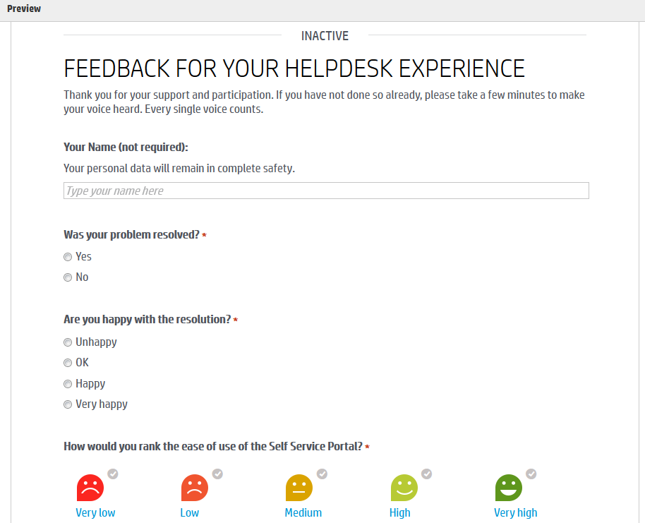

1. From the Mega Menu, select **Build > Survey**.  
   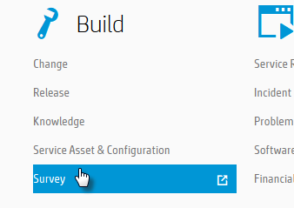
2. In the Survey List, click **New**.  
   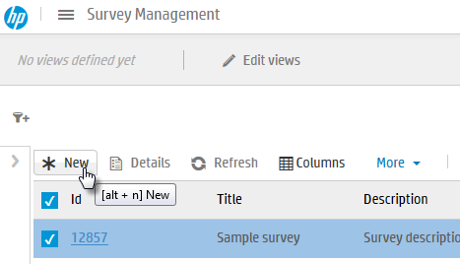
3. Use the following screen print and table to enter the new survey, then click **Save & edit**.  
   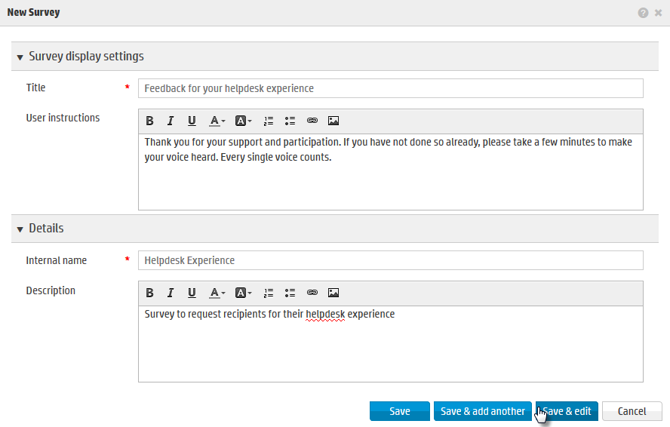

|  |  |
| --- | --- |
| Field | Value |
| Title | Feedback for your helpdesk experience |
| User instructions | Thank you for your support and participation. If you have not done so already, please take a few minutes to make your voice heard. Every single voice counts. |
| Internal name | Helpdesk Experience |
| Description | Survey to request recipients for their helpdesk experience |

1. The new survey will be displayed. Click on the **Workflow** tab.  
   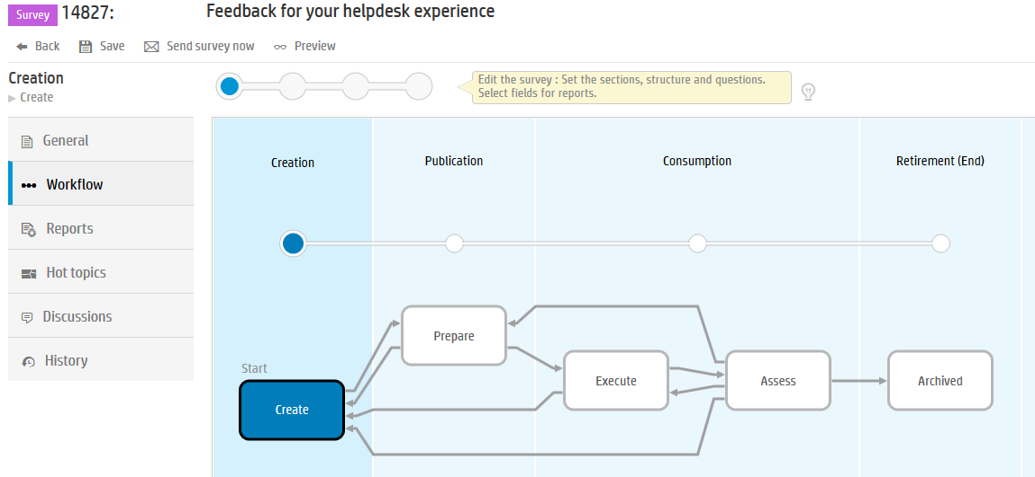  
   The new survey will be in the **Create** phase.
2. Click on the **General** tab and then expand the **Questions** section. This is where we add the questions which will go to the end user.  
   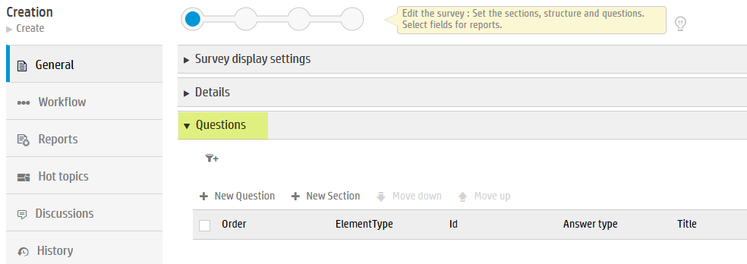
3. In the **Questions** section, click **+ New Question** to add the first question.  
   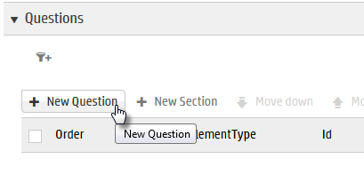
4. Use the following screen print and table to enter the new survey question, then click **Save & add another**.  
   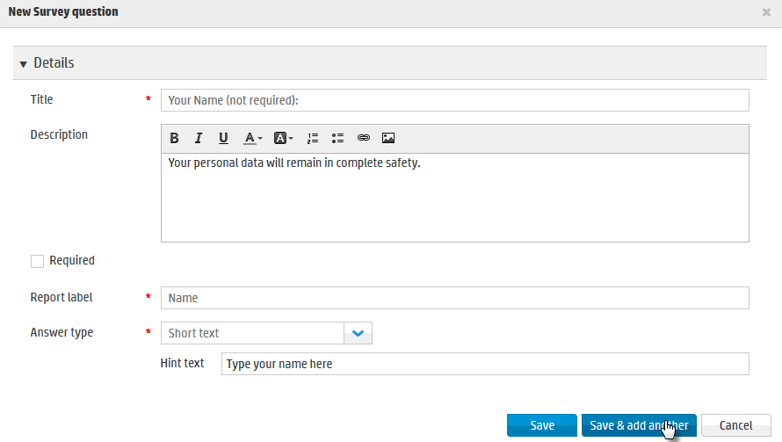

|  |  |
| --- | --- |
| Field | Value |
| Title | Your Name (not required): |
| Description | Your personal data will remain in complete safety |
| Required | *<not selected>* |
| Report label | Name |
| Answer type | Short text *<pick from drop-down>* |
| Hint text | Type your name here |

1. Use the following screen print and table to enter the second survey question, then click **Save & add another**.  
   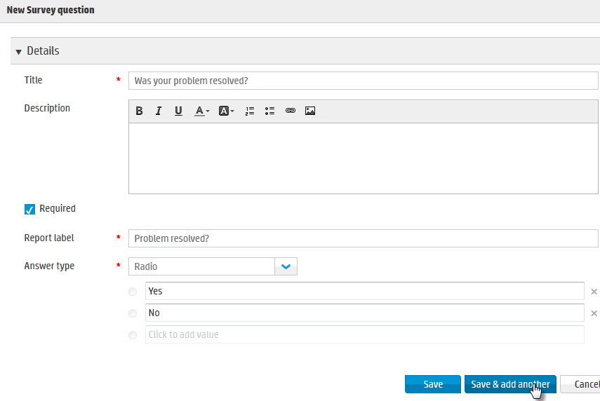

|  |  |
| --- | --- |
| Field | Value |
| Title | Was your problem resolved? |
| Required | *<selected>* |
| Report label | Problem resolved? |
| Answer type | Radio *<pick from drop-down>* |
| Option Values | Yes  No |

1. Use the following screen print and table to enter the third survey question, then click **Save & add another**.  
   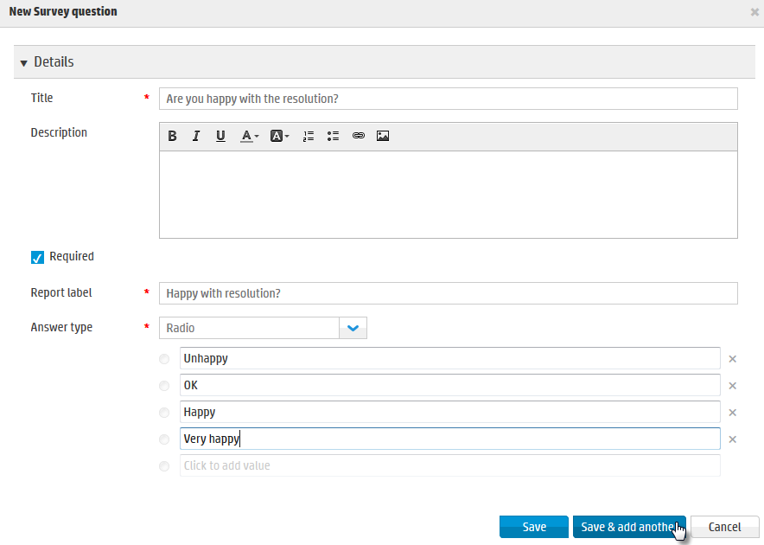

|  |  |
| --- | --- |
| Field | Value |
| Title | Are you happy with the resolution? |
| Required | *<selected>* |
| Report label | Happy with resolution? |
| Answer type | Radio *<pick from drop-down>* |
| Option Values | Unhappy  OK  Happy  Very happy |

1. Use the following screen print and table to enter the fourth and final survey question, then click **Save.**  
   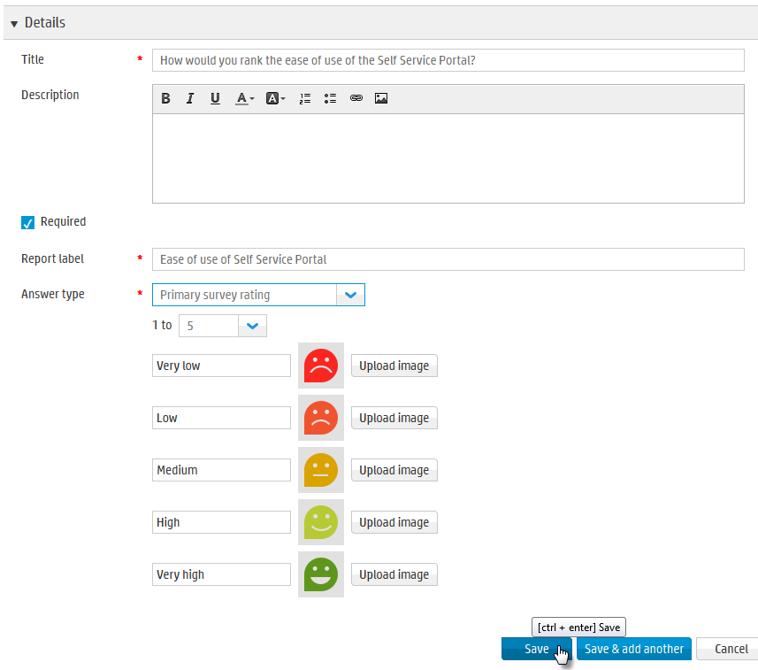

|  |  |
| --- | --- |
| Field | Value |
| Title | How would you rank the ease of use of the Self Service Portal? |
| Required | *<selected>* |
| Report label | Ease of use of Self Service Portal |
| Answer type | Primary survey rating  1 to 5 |
| Values | Very low *<keep default images>*  Low  Medium  High  Very high |

1. The questions in the survey should appear as follows:  
   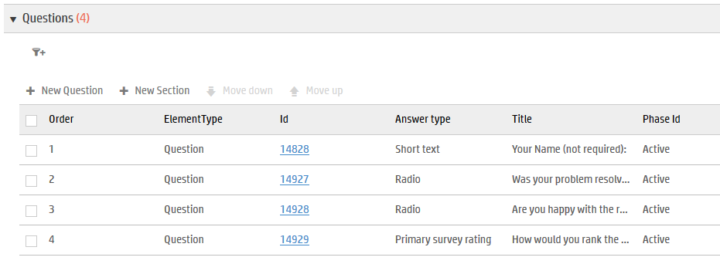
2. In the tray, click **Preview**.  
   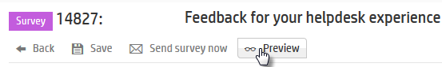  
     
   A preview of your new survey will be displayed. Close the Preview window.  
   
3. Still on the **General** tab, go to the **Report fields** section.  
   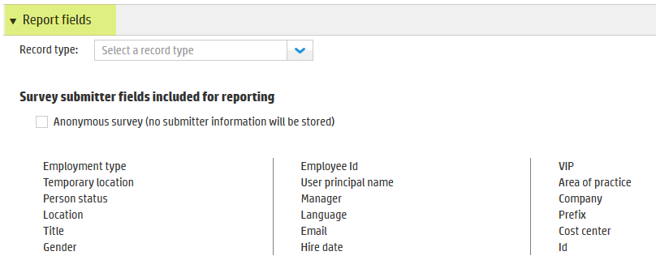  
   Currently this section shows those fields from the person entity table which are exposed to be used for this survey report (when the end user submits a survey). Presently all fields are available to use in the report, as none have a strike-through.  
   Also, this survey is not yet associated with a particular record type (eg. Request).
4. Set the **Record type** to **Request**.  
   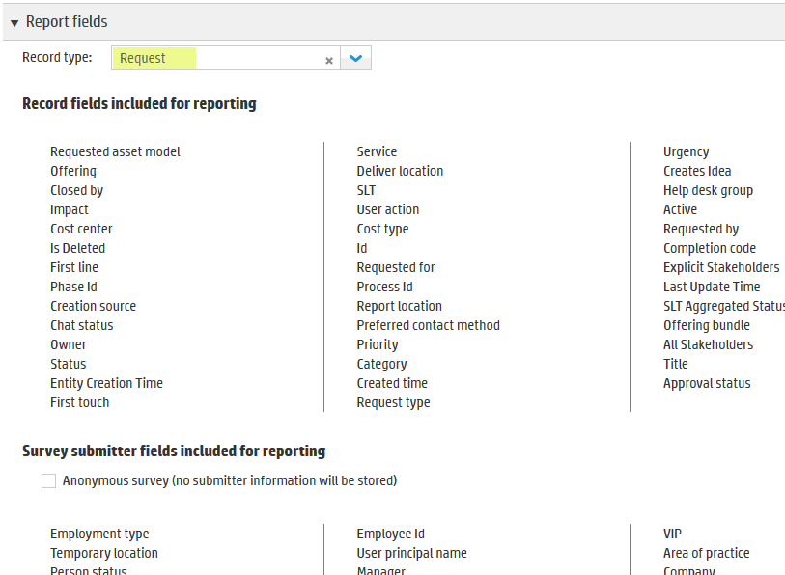  
   This exposes all the fields within the **Request** entity table which are available to be used for reporting.
5. Hover your cursor over the **Requested asset model** field to see an **X** appear to the right of this field. Click the **X**.  
   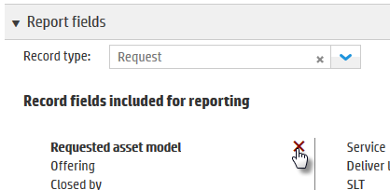  
     
   This will result in this field not being included in the report for this survey.  
   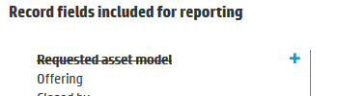
6. Strike out any other fields which you would also not like to be included in the survey.
7. Click the **Save** button.  
   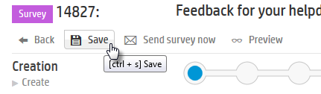
8. In the lifecycle widget, click **Prepare** and then **Save**.  
    
9. Click the **Workflow** tab to see the survey has moved to the **Prepare** phase.  
   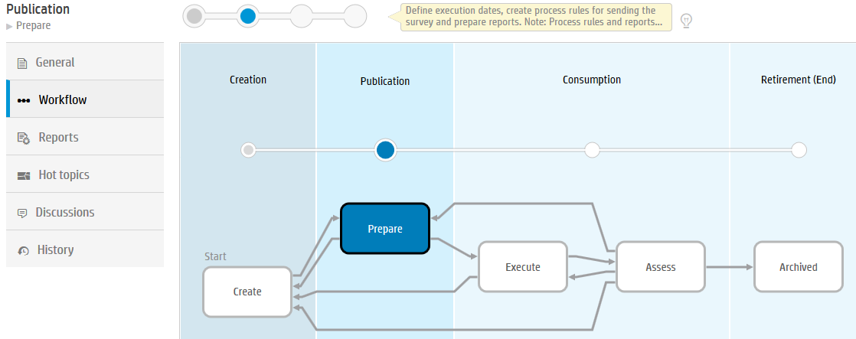

# Task 2: Schedule and Execute the new Survey

In this task you will schedule and then activate the survey.

1. Click on the **General** tab and then go to the **Details** section.  
   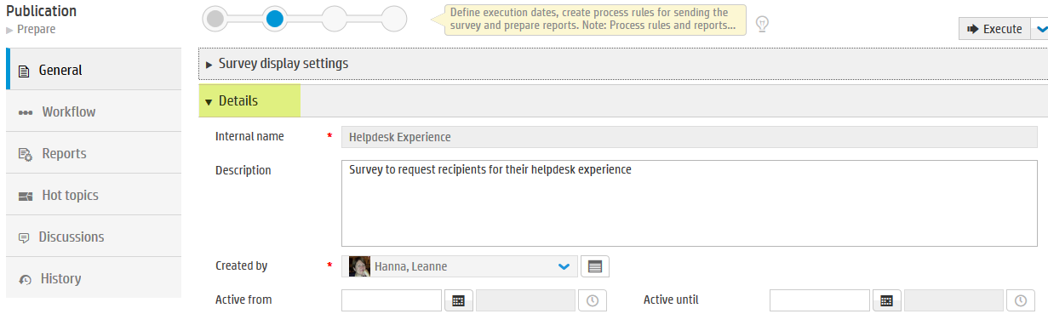
2. In the **Active from** field, set this to yesterday (in the past).  
   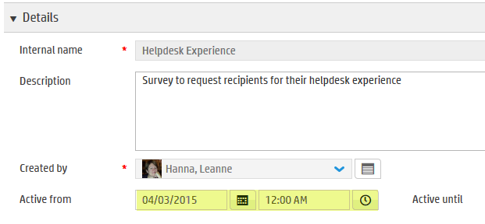
3. In the **Active until** field, set this to next month and then click **Save**.  
   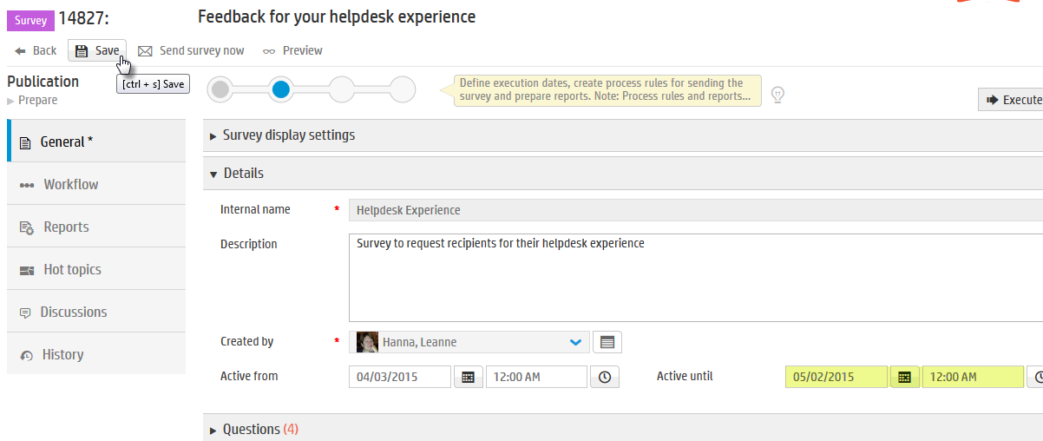
4. In the lifecycle widget, click **Execute** and then **Save**.  
    
5. Click the **Workflow** tab to see the survey has moved to the **Execute** phase.  
   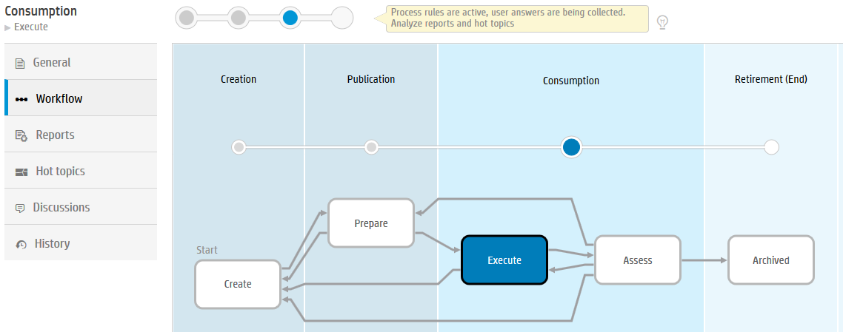  
   The survey is now ready to be used.

# Task 3: Manually test the new Survey

In this task you will manually test the new survey by sending it to amy.lopezmf.

1. Still within the survey, in the tray click **Send survey now**.  
   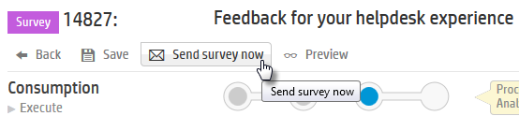
2. In the **Send survey now** pop up, set the recipient as **lopezmf, amy** .
3. In the **Record** drop-down, select any request record from the drop-down list.  
   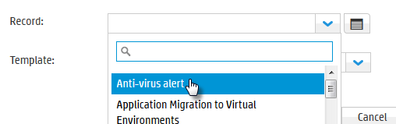  
     
   We are selecting a request record so that in the notification template, values from this request may be used in the email.
4. In the **Template** drop-down, select **Survey default template** and then click **Send**.  
     
     
   **Note**: The Template being used here is a survey template for notification emails. This template is already set up out of the box in Service Anywhere. If you wish to add more templates, this will be covered in the How to Configure and Administer class.
5. A message will be received the notification was successfully sent.  
   
6. Go to the email inbox for amy lopezmf to see the email which has been sent for the survey. If it has not arrived, give it a few seconds to arrive.  
   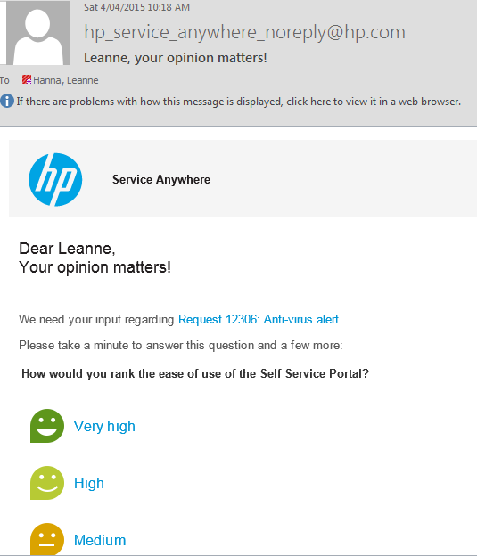
7. ***Either*** click on a link in the survey (one of the values to the right of the faces) which will take you directly to the survey, or go back to your Self Service Portal within Service Anywhere and click your avatar to display the survey.

[Grab your reader’s attention with a great quote from the document or use this space to emphasize a key point. To place this text box anywhere on the page, just drag it.]

1. Hover over the survey and click **TAKE SURVEY**.  
   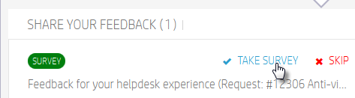  
     
   The survey will be displayed.  
   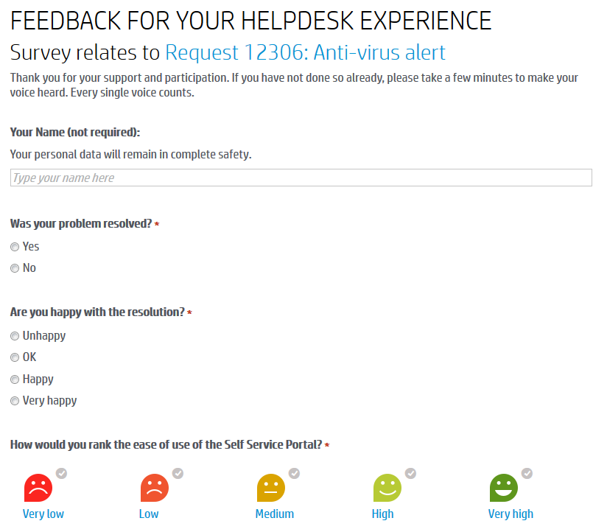
2. Fill in the survey and then click **Submit**.  
   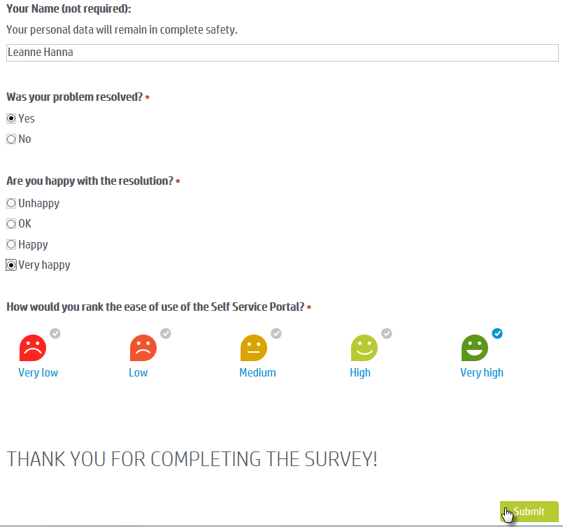

Amy Lopezmf

1. The survey will have been completed.